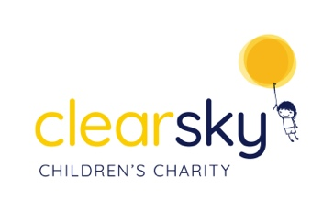

Charity Secretary to the Board of Trustees Job Description

Clear Sky is a charity established to support children and young people who have
experienced trauma and difficult life circumstances through specialist Play & Creative Arts
Therapy services. We believe that children should have the earliest opportunity to make
positive change to help them develop into confident, happy kids!

We are seeking a capable, friendly person to join our Board of Trustees, who meet once per quarter (usually online) to help us to ensure that meetings are efficiently organised and recorded, and that statutory actions are completed in a timely manner. This role would suit someone who is looking to become a Trustee, with good admin skills and enthusiasm for our cause.

Overall purpose

The charity secretary is primarily responsible for the smooth and efficient running of meetings of the trustee board and any sub-committees, providing assistance and support to the chair of the board of trustees.

The charity secretary may also be closely involved in monitoring the requirements affecting the charity and its activities, and ensuring that the trustees’ decisions are acted upon, and that all decisions made by the trustees are in accordance with the governing document, reflect the objects of the charity, and continue to provide public benefit.

The charity secretary should be responsible for keeping the ‘conscience’ of the charity, by way of ensuring that the trustees continue to take decisions and act in line with the governing document and comply with the relevant legislative and regulatory requirements the charity is subject to.

To ensure that other meetings such as AGM, and events are properly administered

To monitor committee member action points.

Specifically:

To have good listening, oral and literacy skills.

To plan and prepare committee meetings and the AGM with others as appropriate. Plan meeting dates, book rooms, send out notifications, minutes and other papers.

Draw up agendas together with the Chair.

Minute committee meetings or ensure another minute taker is available.

Accurately record decisions and actions in the minutes and report to the next committee meeting on the progress of actions and the result of decisions.

Deal with correspondence, writing letters, emails as agreed at committee meetings, summarizing correspondence/emails received at the next committee meetings and drafting replies as appropriate.

Making arrangements for any necessary reporting to be done, for example the annual report to members.

Ensuring that trustee decisions are implemented in accordance with the charity’s governing document or other internal operational procedures.

Knowledge of Charity law and the voluntary sector.

Qualities:
To be organized and methodical.

Able to take good minutes

Able to work as a team and be committed to the charity values

Able to keep accurate records

Relevant skills to organise a meeting well.

